LAB ASSIGNMENT:7.5
NAME: A.Anjali
HALL TICKET:2303A51319
Task 1:
Fixed it by quick error.
Analysis: The function uses a mutable default argument (items=[]). In Python, default mutable objects are created only once and shared across function calls. As a result, values added in previous calls remain in the list, causing unexpected behavior. The issue is fixed by using None as the default value and creating a new list inside the function.
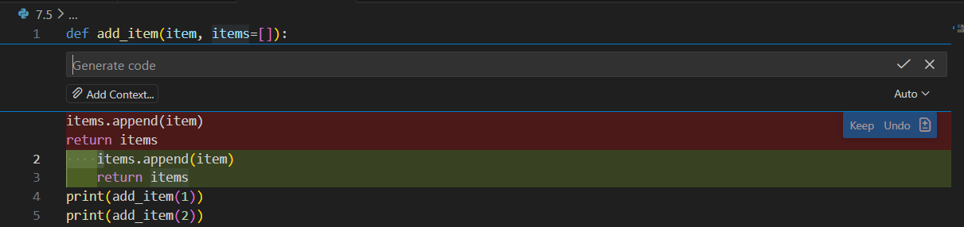

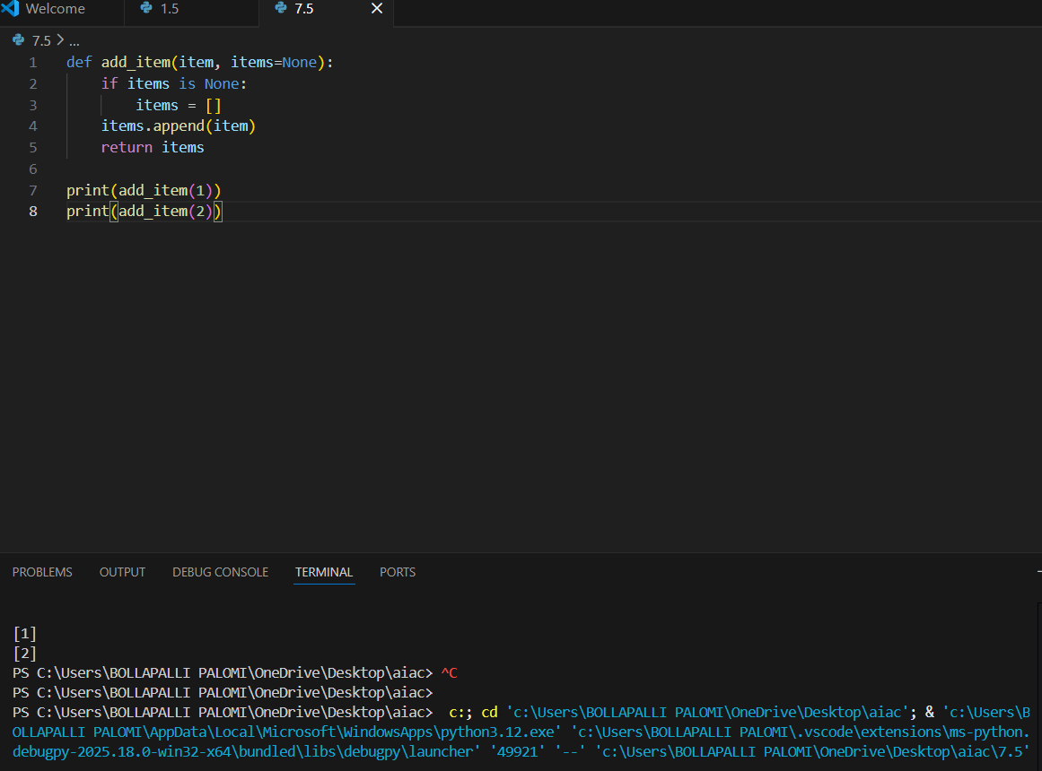
Task 2:
Fixing it by quick error
Analysis: Floating-point numbers cannot always be represented exactly in binary format. Therefore, comparing floating-point values directly using == may return incorrect results. The problem is solved by comparing numbers using a tolerance value, checking whether the difference between them is very small.
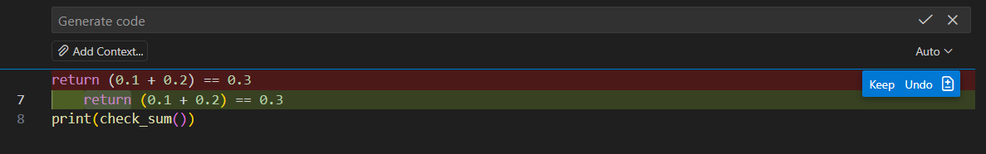
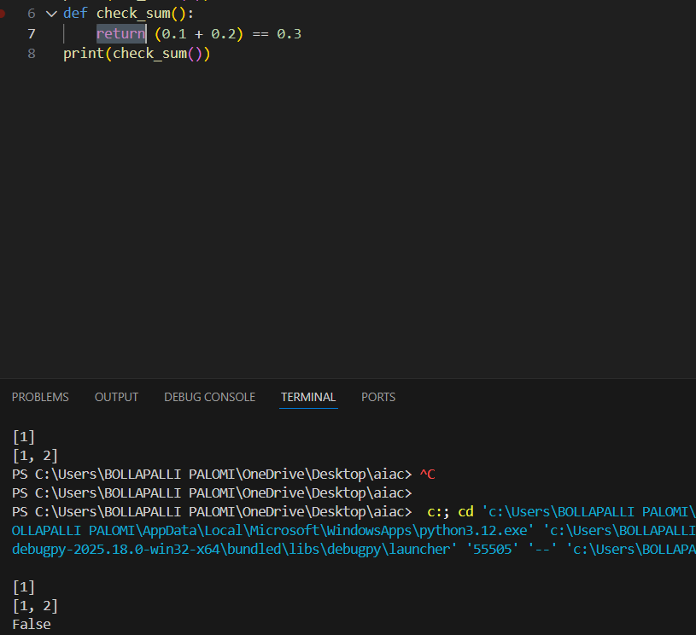
Task 3:
Prompt: Correct recursion with stopping condition.
Analysis: The recursive function calls itself repeatedly without a stopping condition, leading to infinite recursion and a runtime error. Every recursive function must have a base case to terminate execution. Adding a stopping condition prevents infinite calls and ensures correct execution.
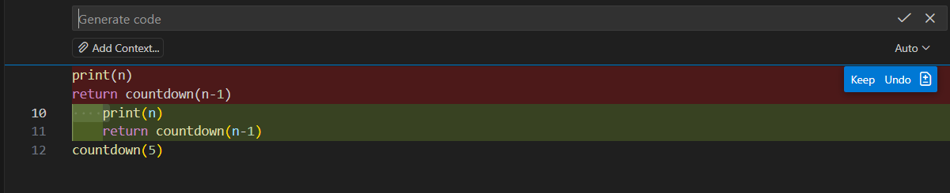
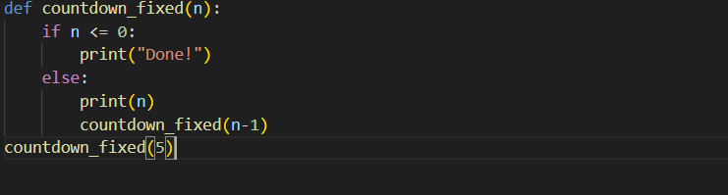
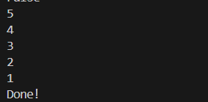
Task 4:
Prompt: Corrected with .get() or error handling.
Analysis: The program tries to access a dictionary key that does not exist, resulting in a KeyError. This happens because dictionaries only allow access to existing keys. The issue can be fixed by using the .get() method or by adding error handling to safely manage missing keys.
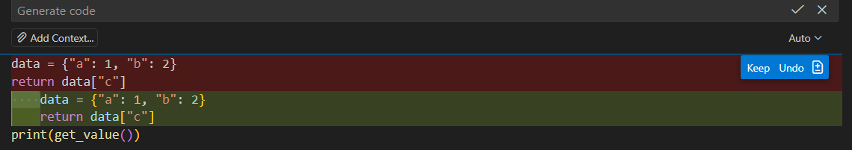
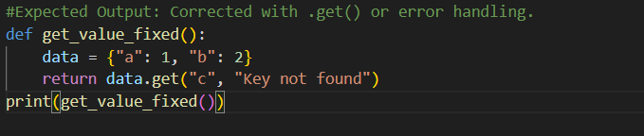
Task 5:
Fixed by quick error
Analysis: The loop condition depends on the variable i, but its value is never updated inside the loop. As a result, the loop condition always remains true, causing an infinite loop. Incrementing the loop variable inside the loop resolves the issue.
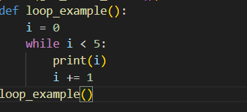
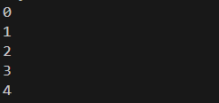
Task 6:
Prompt: Correct unpacking or using _ for extra values.
Analysis: Tuple unpacking fails because the number of variables does not match the number of values in the tuple. Python requires equal numbers during unpacking. The error can be fixed by adding another variable or using _ to ignore extra values.
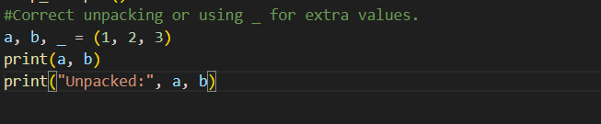

Task 7:
Fixed by quick error
Analysis: Python uses indentation to define code blocks. Mixing tabs and spaces causes indentation errors because Python treats them differently. The issue is resolved by using consistent indentation, preferably four spaces throughout the code.
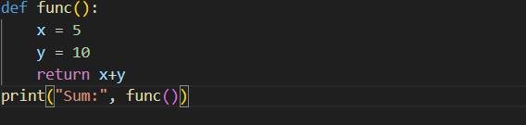
Task 8:
Fix by quick error
Analysis: The program attempts to import a non-existing module named maths. Python provides the correct module as math. Using the correct module name fixes the import error and allows mathematical functions to work properly.
